Turtlebot Demo Manual: Contents
(intended for students at Halmstad U. using ROS Hydro on Ubuntu 12.04)

▪ Setting up/Shutting down Turtlebot

▪ Demos for which only the Turtlebot is required
- Follow-me
- Keyboard Tele-operation

▪ Demos for which the desktop is also required
- Panorama Photo
- Maps and Navigation
- Follow-me (Desktop Version)
- Keyboard Tele-operation (Desktop Version)

▪ General Troubleshooting

Setting up Turtlebot
This red box will say if the demo requires just Turtlebot or also a remote computer

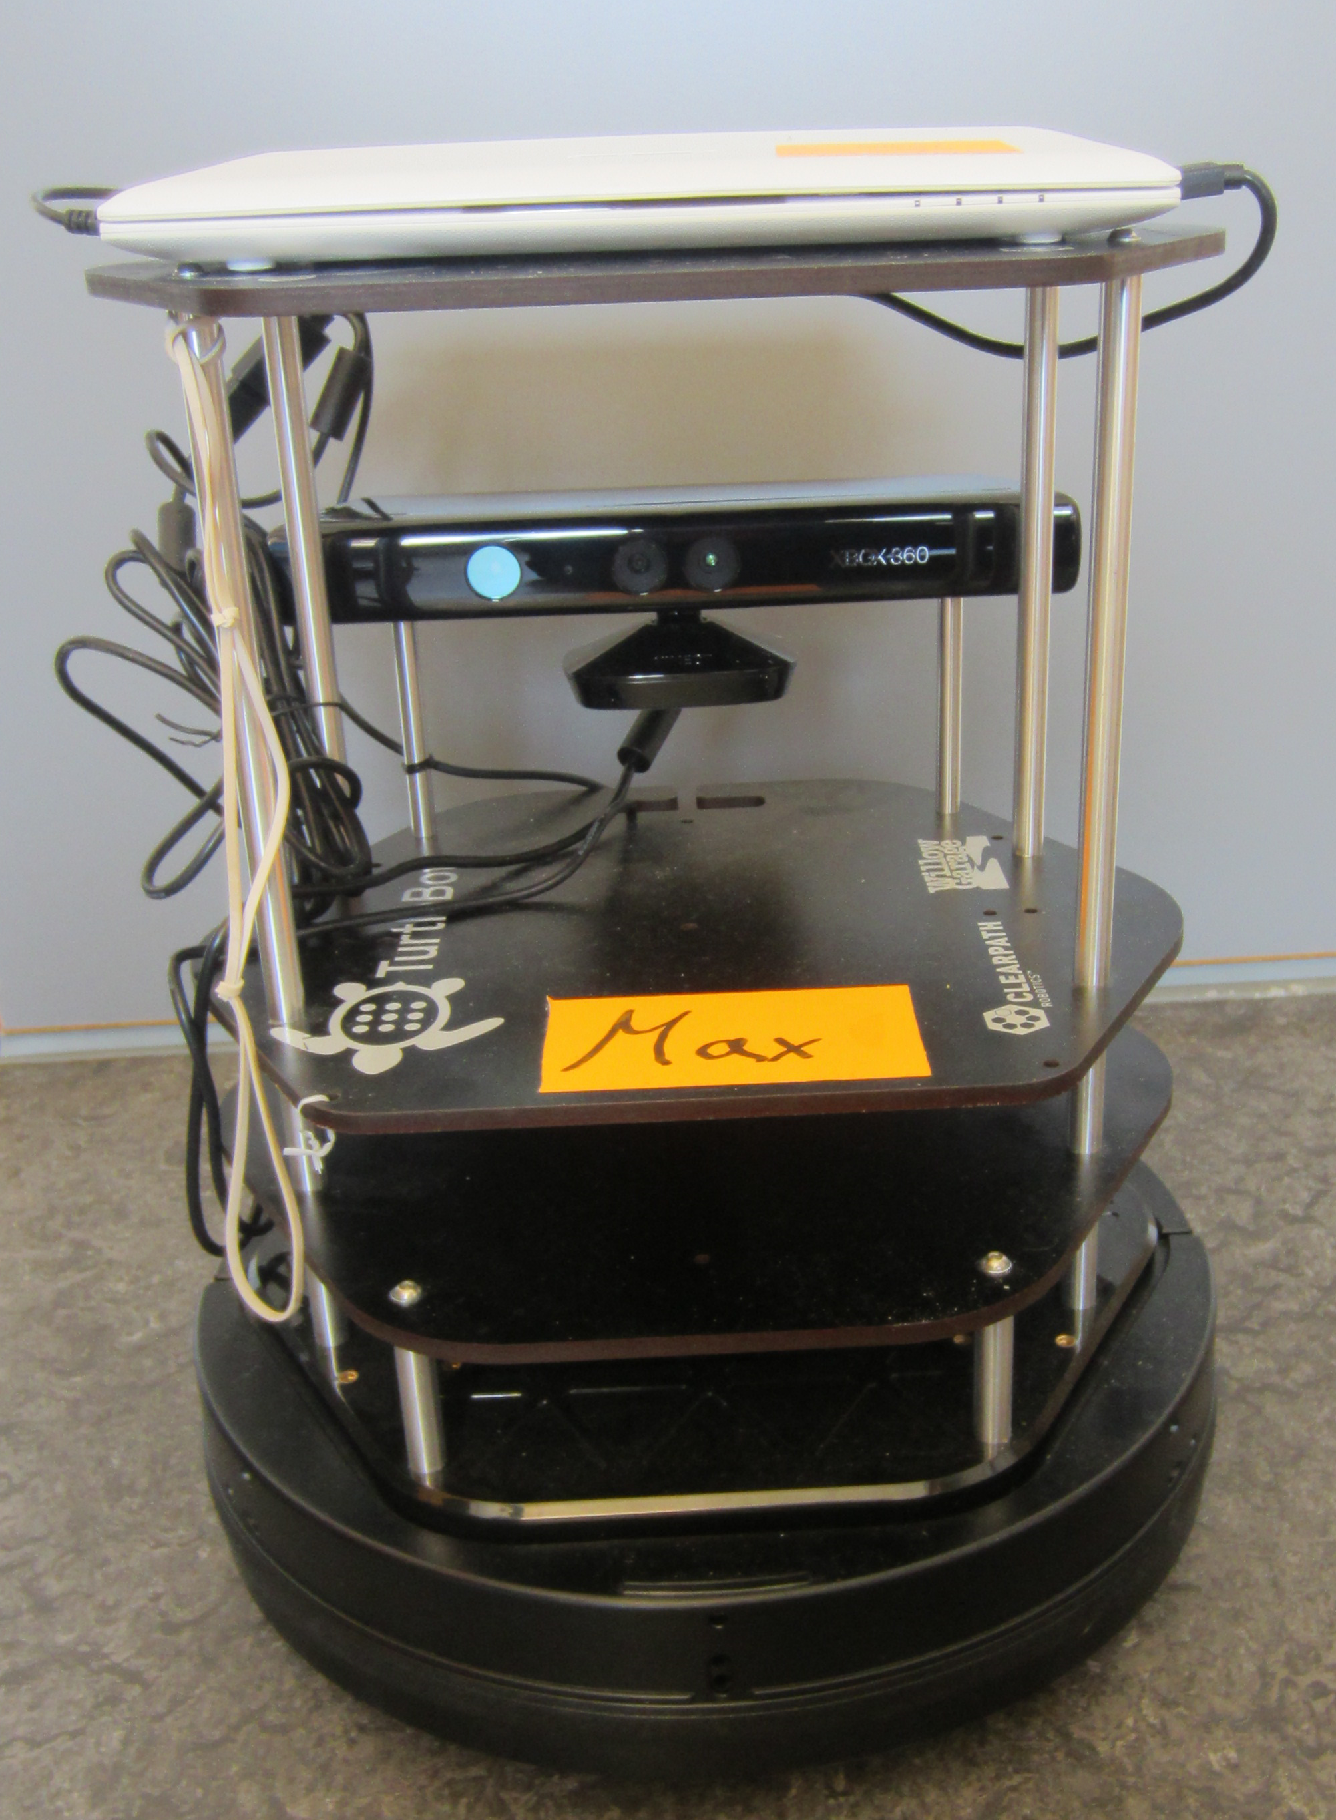Fig. 1 Turtlebot should look like this.

The demos in this guide require either (1) setting up just the Turtlebot or (2) connecting from a remote computer.

Assumed you are using wireless router and not “robotic” network.
Important: you need the password for Turtlebot and/or the desktop (ask Anita, or Martin if you don’t know)

General

-Ensure that the Turtlebot cables are connected properly:
*two black USB cables connect the white ASUS notebook to the Turtlebot base and Kinect like in Fig. 1
*the back of the Turtlebot looks like in Fig. 2
-Flick the power switch on one side of the Turtlebot base shown in Fig. 3 to "on"
The light on the other side of the base should be green like Fig. 4
-Turn on the ASUS notebook
-Next perform either option 1 or option 2, depending on which is required for the demo you wish to perform

Option 1 (just Turtlebot)

-Log in to the ASUS notebook: type “turtlebot” and return, then input the password (ask Anita, or Martin if you don’t know) and return again
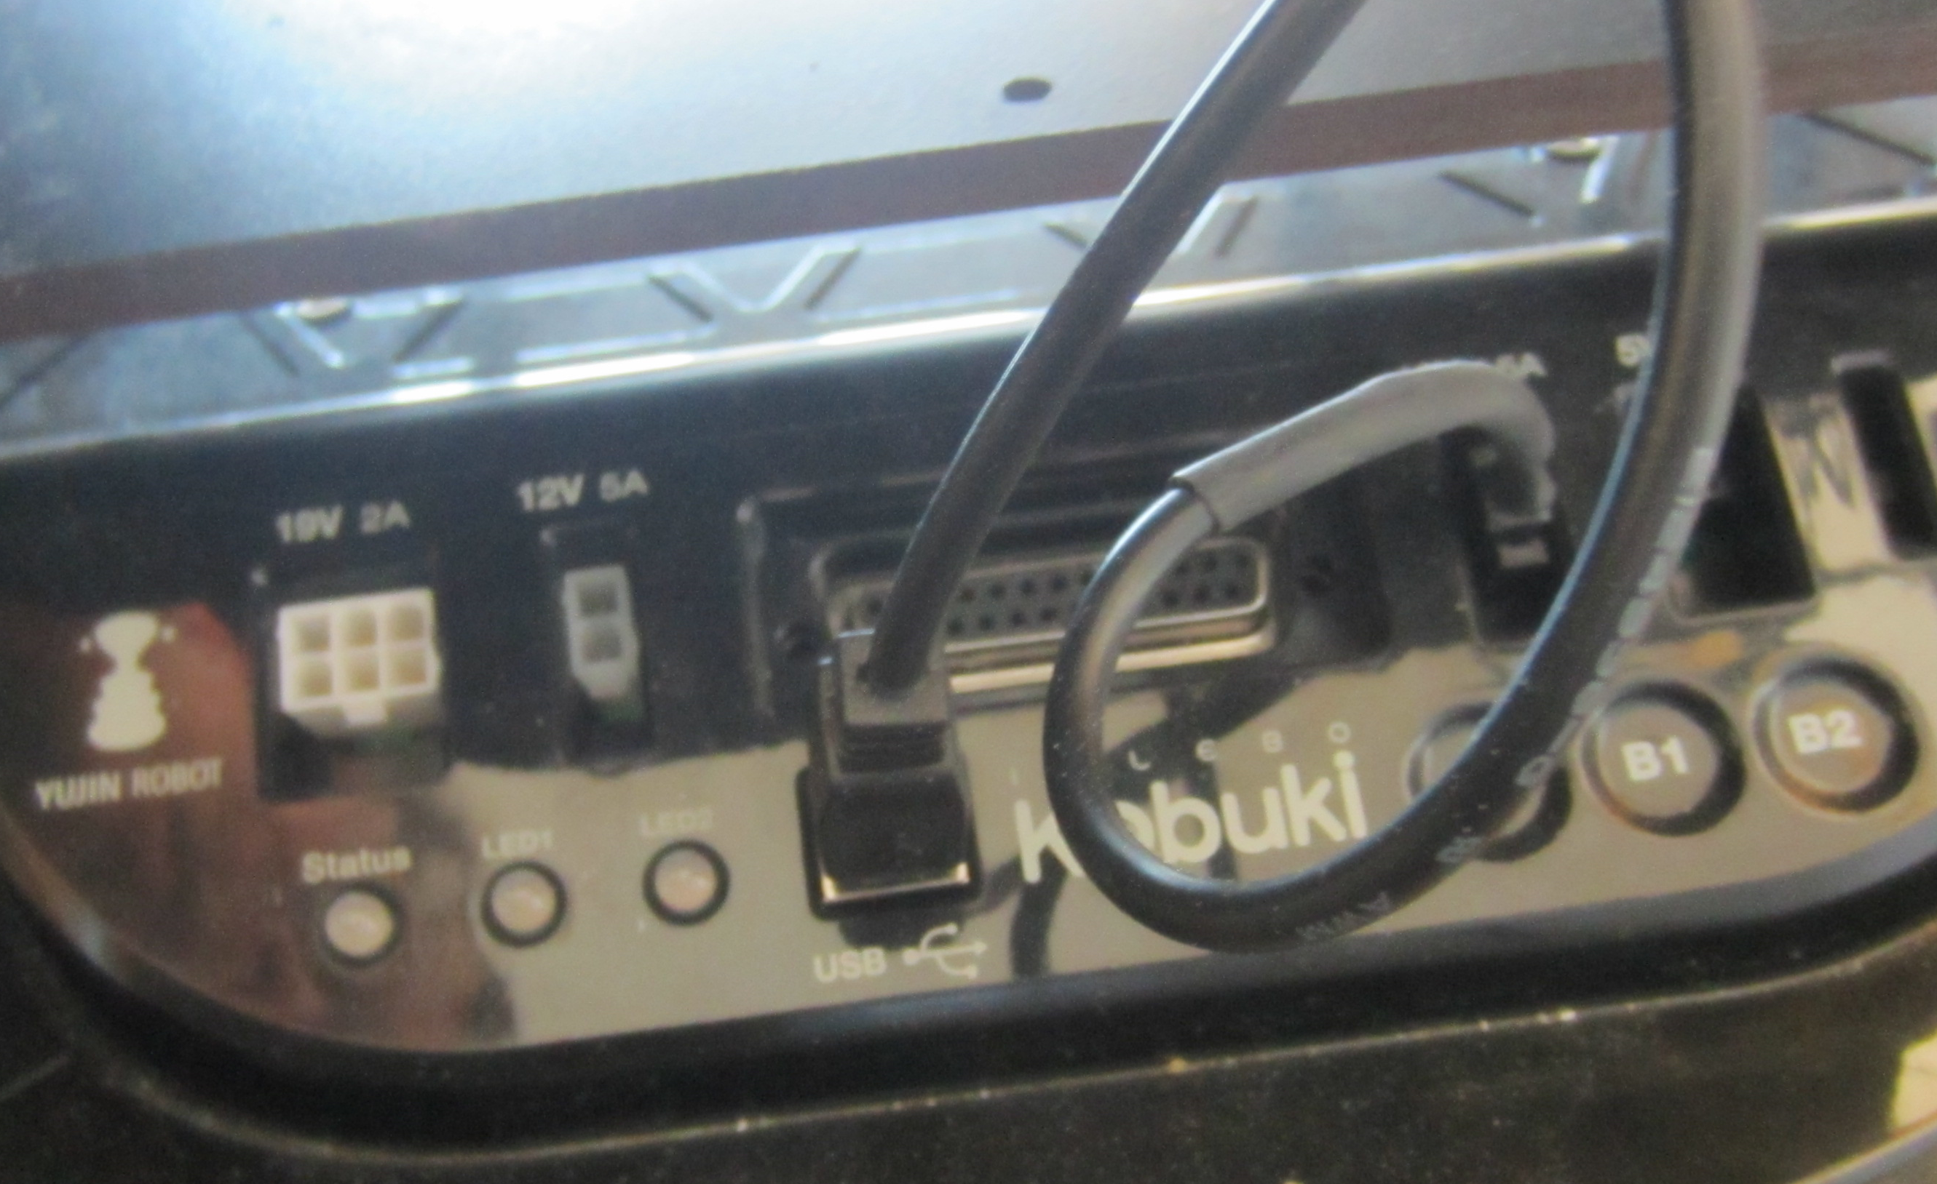Fig. 2 Back of Turtlebot.

Option 2 (Turtlebot and desktop):

When the ASUS notebook starts up (text appears), you can close the lid
Fig. 2 Back of Turtlebot.
-Turn on the desktop and login with your user id and the password (ask Anita, or Martin if you don’t know)
-Turn on the wireless router next to the desktop (it has a pressable power button on its lower backside)
-Open an appropriate number of black windows on the desktop by pressing Ctrl-Alt-T or clicking the K button at the bottom left side on Kubuntu, then “Terminal”; you can open new ones after opening one with ctrl-shift-n
-To connect to Turtlebot, type “./sshturtle" or “. . . 2” in /scripts or /martin folder (you can also type something like "ssh turtlebot@192.168.10.101" or “. . . 102” and the password if you wish); if this does not work wait for a few seconds and try again; if it still does not work check that the router is on, the ASUS notebook is on, that the ASUS notebook is connected to the network
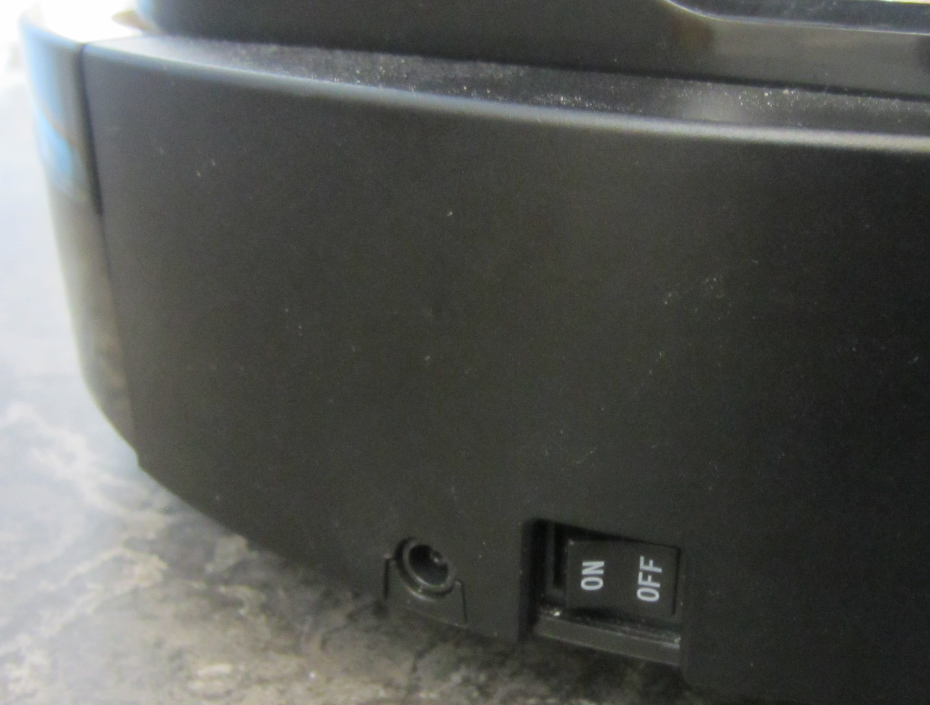
Fig. 3 Turtlebot power button (off).
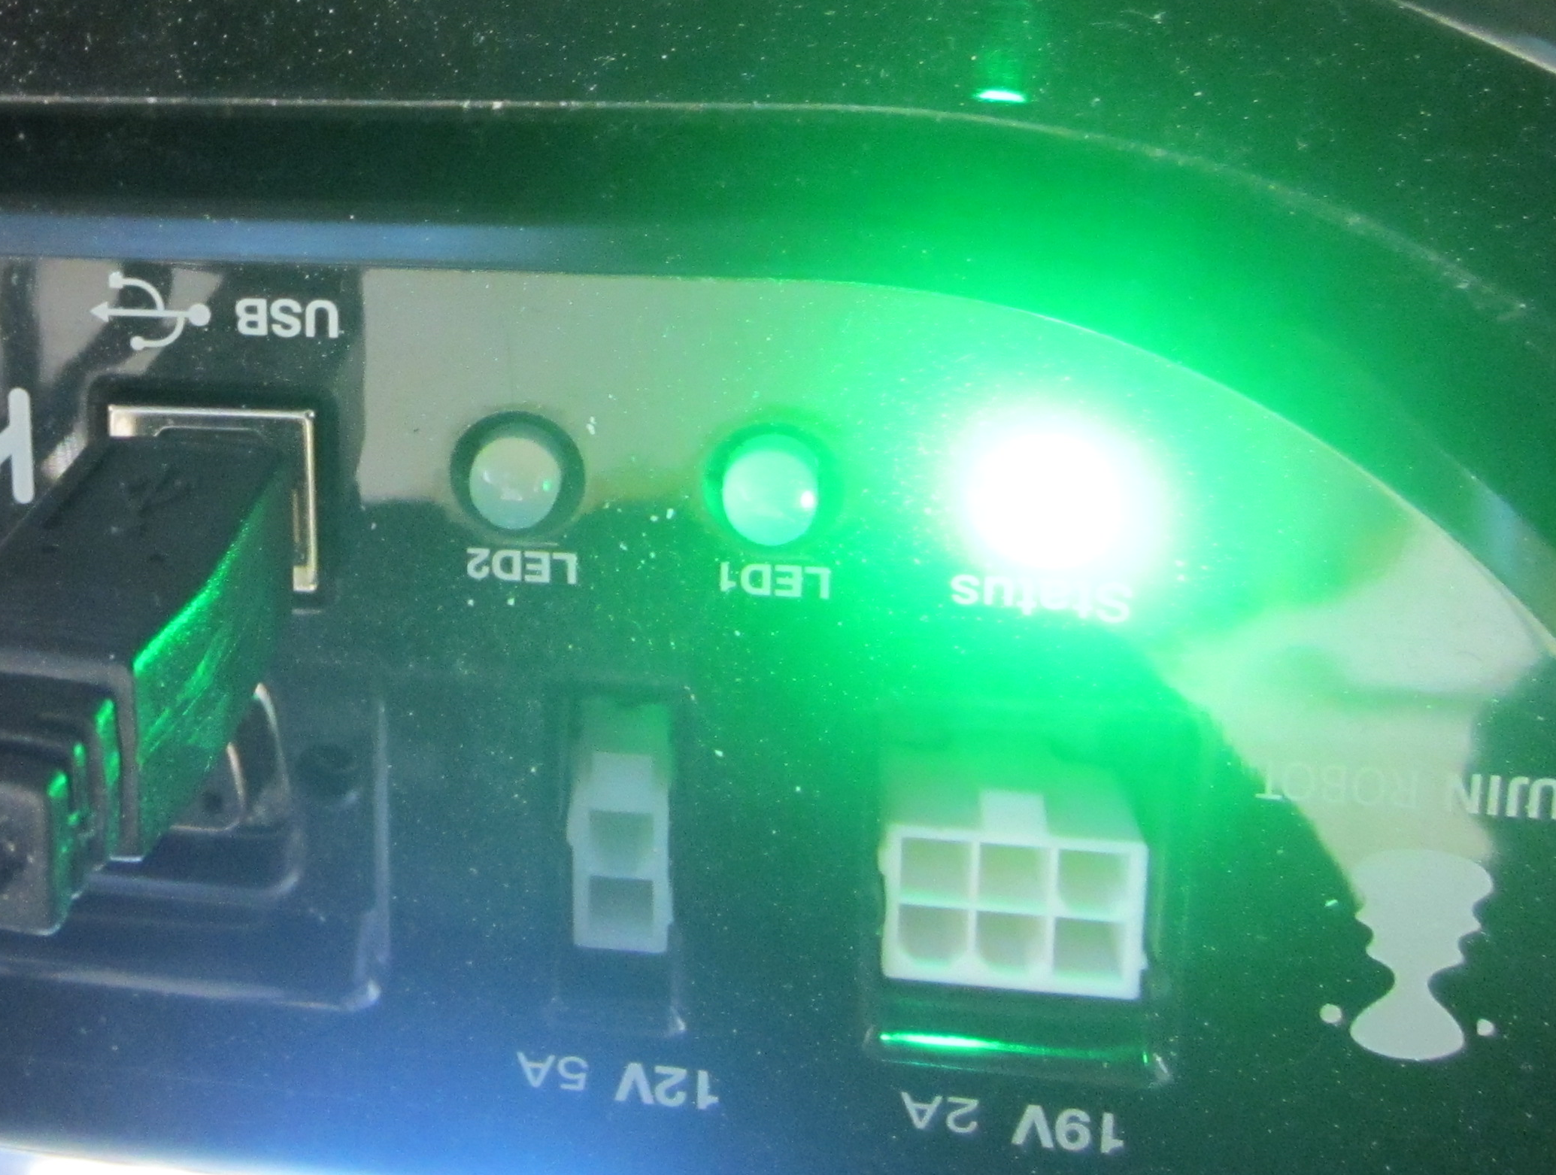
Fig. 4 Light shows battery level.

Shutting down Turtlebot

Option 1 (just Turtlebot)

-Press Ctrl-C in the notebook, then Alt-F1, then Ctrl-C again to turn off the robot’s programs. You will hear a little song again.

Option 2 (Turtlebot and desktop):

-Press Ctrl-C in the black windows on the desktop in reverse order to turn off the robot’s programs. You will hear a little song again.

General
If you are not going to perform any other demos, type in "sudo shutdown -P now" then the password to turn off the notebook, then turn off the robot’s power, desktop and router.

Manual for Turtlebot Follow-me Demo
Requires only Turtlebot

Set-up

-Perform set-up as described at the start of the manual with Option1: just Turtlebot.

Demo:

-Type in "roslaunch turtlebot_bringup minimal.launch" on the ASUS notebook and return
After a few seconds, you should hear a little song

-Type Alt-F2 to bring up a new screen
You will again have to type in “turtlebot” + password

-In the new screen, type in
"roslaunch turtlebot_follower follower.launch" + return

-Perform the demo
Standing in front of the robot, back away slowly and the robot should follow. You can also try to slowly chase the robot.

Clean-up:

-Shut down the robot as described at the start of the manual with Option1: just Turtlebot.

Congratulations! You can now control the Turtlebot!

Manual for Turtlebot Keyboard Operation
Requires only Turtlebot

This simple demo allows you to send commands for the Turtlebot to move from a keyboard.

Set-up

-Perform set-up as described at the start of the manual with Option1: just Turtlebot.

Demo:

-Type in "roslaunch turtlebot_bringup minimal.launch" and return
After a few seconds, you should hear a little song
-Type Alt-F2 to bring up a new screen
You will again have to type in “turtlebot” + return twice
-In the new screen, type in
"roslaunch turtlebot_teleop keyboard_teleop.launching" + return
This sets up the demo.
-Perform the demo
You can now control the robot to move using the keys:
u i o
j l
m , .
which should make the robot go forward, left, right, and backward

Clean-up:

-Shut down the robot as described at the start of the manual with Option1: just Turtlebot.

Congratulations! You can now tele-operate the Turtlebot to do your bidding!

Manual for Turtlebot Panorama Demo
Requires Desktop

Let’s take a panorama photo using the Turtlebot!
Set-up
-Perform set-up as described at the start of the manual with Option2: Turtlebot and desktop, and opening four black windows.

-Ssh into Turtlebot (as described in “setting up Turtlebot: option 2”) and type in "roslaunch turtlebot_bringup minimal.launch" and return
After a few seconds, you should hear a little song
-Ssh into Turtlebot and input "roslaunch turtlebot_panorama panorama.launch".
This sets up the robot to perform the demo
-In a third black window, type in "rosrun rviz rviz" and return.
This will start up the “Rviz” program which will show you the panorama shot.
When the program starts up, click on the dropdown list to the right of “fixed frame” and set the selected option to "camera_rgb_optical_frame"
Click “Add” on the left and select "Image".
Expand the options for “Image”. Click on the dropdown list for “image source” and select "/turtlebot/panorama/panorama"
You may see an exclamation mark by Image because you are not receiving data yet. This is fine.
Demo:
-In the fourth black window, input "rosservice call turtlebot_panorama/take_pano 1 360.0 30.0 0.1"
This calls for the robot to slowly turn 360 degrees, taking snapshots. If you wish, you can bend down in front of the robot or maybe only your ankles will be photographed!
-When the robot has finished, input “rosservice call turtlebot_panorama/take_pano 2 360.0 30.0 0.1”
This indicates that the robot has finished and the process should end.
-You should see a panorama shot in the lower left hand side of Rviz; you can enlarge this window to see better. Congratulations! You now have a robotic cameraman! Why not save your accomplishment by taking a snapshot with the “PrtScn” button on the desktop?
Clean-up:
-Shut down the robot as described at the start of the manual with Option2: Turtlebot and Desktop.

TROUBLE-SHOOTING
*The Rviz program often has problems. If it does not let you select anything from a dropdown list or you do not see a panorama photo, try the following:
-Press Ctrl-C to end Rviz and restart the program.
-Open a fifth black window and input “rosrun rqt_reconfigure rqt_reconfigure”
Select “camera” then “driver” from the drop-down menu. Try checking/unchecking the depth_registration checkbox, and waiting a few seconds, while checking Rviz.
*If a nice panorama photo is not being generated, you can try adjusting the parameters in the rosservice call: e.g., change “0.1” to “0.5” to get the robot to turn faster

Manual for Turtlebot Navigation Demo
Requires Desktop

This demo allows you to command the robot to go somewhere using a map!
Set-up
-Perform set-up as described at the start of the manual with Option2: Turtlebot and desktop, and opening five black windows.
-Ssh into Turtlebot (as described in “setting up Turtlebot: option 2”) and type in "roslaunch turtlebot_bringup minimal.launch" and return; after a few seconds, you should hear a little song
-In another black window, ssh into Turtlebot, then input
"roslaunch turtlebot_navigation gmapping_demo.launch".
This sets up the robot to perform the demo
-In a third black window, input
"roslaunch turtlebot_rviz_launchers view_navigation.launch".
This should start up the “Rviz” program which will show you the map.
Rviz should be showing the robot’s view. If not, please fiddle with settings.
-In the fourth black window, input
“roslaunch turtlebot_teleop keyboard_teleop.launch”
This will let you teleoperate the robot to drive around and build the map
Phew! Finally you have finished setting up the demo.

Demo:
-Drive the robot around at a medium speed, tracing all walls in the area you wish to map.
-When you are finished, in the fifth black window, input “rosrun map_server map_saver -f /tmp/my_map”
This will save the map to /tmp in your root directory as two files, yaml and
You have successfully built a map using Turtlebot!
But watch out! Files in the /tmp directory can be automatically deleted.
If you wish, you can save your map in a different directory, and view it at any time with an image viewer.
Now, let’s see how you can use your map to let the robot navigate!
-input “roslaunch turtlebot_navigation amcl_demo.launch map_file:=/tmp/my_map.yaml”
Change the last part if you have saved your map in a different directory
-In the “Rviz” program, click "2D Pose Estimate" at the top.
Click on the map where the TurtleBot approximately is and drag in the direction the TurtleBot is pointing.
-Click the "2D Nav Goal" button
Click on the map where you want the TurtleBot to drive and drag in the direction the TurtleBot should be pointing at the end.
Now the Turtlebot should now move according to your command!
Be careful to avoid having the Turtlebot run against an obstacle, which can damage it.

Clean-up:
-Shut down the robot as described at the start of the manual with Option2: Turtlebot and Desktop.
TROUBLE-SHOOTING
*The Rviz program often has problems. If it does not let you select anything from a dropdown list or you do not see a panorama photo, try the following:
-Press Ctrl-C to end Rviz and restart the program.
-Open a fifth black window and input “rosrun rqt_reconfigure rqt_reconfigure”
Select “camera” then “driver” from the drop-down menu. Try checking/unchecking the depth_registration checkbox, and waiting a few seconds, while checking Rviz.
*If your computer says it cannot find the launch file: you need to install:
“sudo apt-get install ros-hydro-turtlebot-apps ros-hydro-turtlebot-rviz-launchers”

Manual for Turtlebot Follow-me Demo
Desktop Version

Set-up
-Perform set-up as described at the start of the manual with Option2: Turtlebot and desktop, and opening two black windows.

-Ssh into Turtlebot (as described in “setting up Turtlebot: option 2”) and type in "roslaunch turtlebot_bringup minimal.launch" and return; after a few seconds, you should hear a little song

-In the other black window, ssh into Turtlebot and type "roslaunch turtlebot_follower follower.launch" + return
This sends a message to start the demo

Demo:
-Perform the demo
Standing in front of the robot, back away slowly and the robot should follow. You can also try to slowly chase the robot.

Clean-up:
-Shut down the robot as described at the start of the manual with Option2: Turtlebot and Desktop.

Congratulations! You can now control the Turtlebot!

Manual for Turtlebot Keyboard Operation
Desktop Version

This simple demo allows you to send commands for the Turtlebot to move from a keyboard.

Set-up
-Perform set-up as described at the start of the manual with Option2: Turtlebot and desktop, and opening two black windows.
- Ssh into Turtlebot (as described in “setting up Turtlebot: option 2”) and type in "roslaunch turtlebot_bringup minimal.launch" and return; after a few seconds, you should hear a little song

Demo:
-In the second screen, ssh into Turtlebot and type in
"roslaunch turtlebot_teleop keyboard_teleop.launching" + return
This sets up the demo.
-Perform the demo
You can now control the robot to move using the keys:
u i o
j l
m , .

Clean-up:
-Shut down the robot as described at the start of the manual with Option2: Turtlebot and Desktop.

Congratulations! You can now tele-operate the Turtlebot to do your bidding!

GENERAL TROUBLE-SHOOTING

Batteries: if the light on the robot’s base is not green (e.g., yellow) or the Asus notebook screen is black and unresponsive:
Try recharging

Network: if you see an error message saying: computer cannot talk to ROS master:
The problem is likely (1) the ip addresses in ~/.bashrc, or (2) network related
(1)check “ifconfig” in ASUS and desktop to get the ip addresses of the notebook and your desktop
type "sudo vi ~/.bashrc" and the password if prompted
scroll to the end of the file
check the two lines near the bottom which say ROS_HOSTNAME and ROS_MASTER_URI:
the ip addresses should be the same as what you saw with ifconfig
on the desktop, the master should have the ip address of your asus notebook and hostname should be the ip address for the desktop; on the notebook both will be the ip address of the notebook
if the addresses aren’t what they should be, you’ve found a problem, rejoice!
press “I” to go into insert mode
create a backup of the current lines by copy and pasting and commenting out the old pair with a “#” at the start of the line
change the new pair to the correct ip addresses (and port if needed)
if the ip addresses were correct, a problem can still result when you have multiple lines for ROS_HOSTNAME and ROS_MASTER_URI; ensure that each of these is only defined once
also ensure there is a “http://” before the ip address for the master.
type ESC, “:wq!” to save and exit
(if you made a mistake you can instead leave without saving and go back in again with esc+ “:q!”)
close your old terminals and open new ones
you can also type “bash --login” to reupdate an old terminal after you’ve made changes
try to restart the turtlebot

other problems: try pinging, if it fails, reconnect to network (through gui, or sudo ipconfig wlan0 down, sudo ipconfig wlan0 up, or restart computer)
you may also have to edit “/etc/network/interfaces” then “/etc/init.d/networking restart”

Viewing: the Rviz program often has problems. If it does not let you select anything from a dropdown list or you do not see a panorama photo, try the following:
-Press Ctrl-C to end Rviz and restart the program.
-Open a fifth black window and input “rosrun rqt_reconfigure rqt_reconfigure”
Select “camera” then “driver” from the drop-down menu. Try checking/unchecking the depth_registration checkbox, and waiting a few seconds, while checking Rviz.

Kinect not working. Try fiddling with cable, start up nodes again.

Database. If access is denied, you may have to edit pg_hba.conf. you can “find –name “pg_hba.conf”” to locate this, but it will be in something like “/etc/postgresql/X.X/main”
Or, you may have to edit the connection info in your source c++ file and recompile with catkin_make

Launch files not found. Check that you have installed needed files:
“sudo apt-get install ros-hydro-turtlebot-apps ros-hydro-turtlebot-rviz-launchers”

